Problem 1:

You have a list of departments, each containing a list of employees.

1. Combine all employees from the departments into a single list.
2. Identify employees whose names begin with a specified letter.
3. Arrange these employees' names in alphabetical order.
4. Gather the sorted names into a list for each starting letter.
5. Create five Sports team with each team containing randomized employees
6. Merge the five Sports stream into three divisions

***Code –***

***Output –***

Problem 2:

Find the frequency of each character in a string using Java streams

***Code –***

package Day2;  
import java.util.*;  
import java.util.stream.Collectors;  
  
public class Freqmap {  
 public static void main(String[] args) {  
 Scanner scanner = new Scanner(System.*in*);  
 System.*out*.print("Enter a string: ");  
 String input = scanner.nextLine();  
 Map<String, Long> frequencyMap = Arrays.*stream*(input.split(""))  
 .collect(Collectors.*groupingBy*(c -> c, Collectors.*counting*()));  
 frequencyMap.forEach((key, value) -> System.*out*.println(key + ": " + value));  
 }  
}

***Output –***

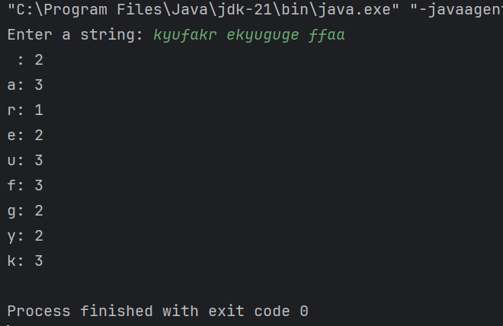

Problem 3

Given a list of Student names add the correct Prefix to the names of the students using their Gender

***Code –***

package Day2;  
import java.util.*;  
import java.util.stream.*;  
  
class Student {  
 String name;  
 String gender;  
 public Student(String name, String gender) {  
 this.name = name;  
 this.gender = gender;  
 }  
 public String getName() { return name; }  
 public String getGender() { return gender; }  
}  
  
public class Pref {  
 public static void main(String[] args) {  
 List<Student> students = Arrays.*asList*(  
 new Student("Aman", "Male"),  
 new Student("Kushagi", "Female"),  
 new Student("Ankita", "Female"),  
 new Student("Sanskar", "Male"),  
 new Student("Dixit", "Male"));  
 List prefixedNames = students.stream()  
 .map(s -> (s.getGender().equalsIgnoreCase("Male") ? "Mr. " : "Ms. ") + s.getName())  
 .collect(Collectors.*toList*());  
 System.*out*.println(prefixedNames);  
 }  
}

***Output –***

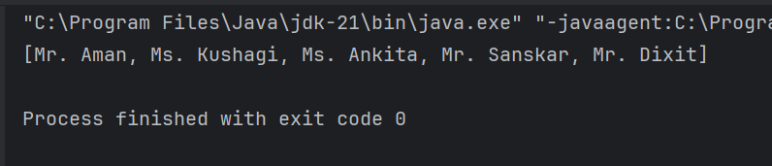

Problem 4

You have a list of laptops with their configurations.

1. Write a function to find all laptops that have at least the specified RAM capacity and graphics card capacity.
2. Group these laptops by their processor model.
3. Sort the laptops within each group by memory, hard disk size, and date of manufacturing.

***Code –***

***Output –***